1.

Samsung’s Galaxy Fold, a foldable smartphone released in 2019 reflects a significant innovation within the smartphone industry. The device in question utilises flexible display technologies, which represent a revolutionary development in the display market. Flexible displays reflect a more versatile alternative to traditional flat screen displays, owing to their flexibility to be suited to a broader range of use cases. Notably, Samsung’s innovation affords users the ability to manipulate the size of its display in order to store it in a smaller space. This has been made achievable recently through innovations in display technology, and most notably, the development of OLED (organic light emitting diodes). This has facilitated the development of extremely thin film stacks, which are able to sustain repeated bending cycles, when aided by the protection of a thin layer of plastic. These physical, operational and functional characteristics are key to the value proposition put forth by Samsung’s Galaxy Fold Phone.

The market potential for this product is huge as the versatility of the Galaxy Fold facilitates a broad range of applications. The primary use cases for this technology are derived from its ability to augment display technologies by increasing the portability of larger displays. This innovation provides improvements media consumption and productivity for users, as larger displays contribute towards a more immersive experience and provides additional screen real estate for productivity work. Users who would benefit from these innovations include both the broader consumer market and businesses. The most prolific use case for flexible display technology is in smartphones, and most notably, foldable devices. as consumers seek large displays that can simultaneously fit in their pockets. Industry trends reflect a desire for larger screen size amongst consumers, a notion which is illustrated by Fig 1. (Scarsella and Stofega, 2019), which showcases increasing demand for devices which cater towards this preference.

However, given the infancy of this technology, the market for devices with flexible displays has been somewhat limited, as there are significant barriers to entry for initial adopters in the form of high costs. For example, Samsung’s first iteration in its foldable phone line, 2019’s Galaxy Fold, carried a launch price of $2999 AUD, more than double that of its flagship Galaxy S10 phone ($1349 AUD). Resultantly, the market for early iterations of phones with flexible displays has mostly been relegated to enthusiasts and high-income consumers, and notably, does not cater to the raging demand for smartphones in developing countries, a phenomenon which is reflected in Fig. 2. Nonetheless, the potential for broad adoption in the future as economies of scale is achieved is exceptional.

Furthermore, the advent of foldable phones has led to increased opportunities for the development of complementary products, including foldable phone cases and screen protectors. Samsung's product faces substitute products which it must compete with in the product. These include traditional smartphones and tablet devices, which are currently available at a lower price and with a greater variety of features and specifications. Consideration of these competing devices is crucial to developing a foothold in the market.

There are several levels of competition in the product market for Samsung's foldable phone. Chiefly, the product market structure for Samsung's foldable phone is characterised by a complex web of dynamic inter category relationships with both complementary and supplementary goods. This is because Samsung’s product represents a complementary bundle, offering the screen real estate of a tablet in the form factor of a phone, and therefore, can serve as a substitute for both phones and tablets, individually. (Shocker, Bayus and Kim, 2004). This product market can be identified through a substitution-in-use analysis. Key to this process is the consideration of Samsung’s target market, coupled with an understanding of similar products which fulfill these customers' use scenarios. Analysing the similarity of consideration sets reveals that the conditions which precede Samsung’s product market are the product of consumers looking for devices which fulfill similar use scenarios, namely tablets and phones, a notion which is reflected in the table in Fig 3.

|  |  |  |  |
| --- | --- | --- | --- |
| **Level of competition** | **Definition** | **Competitors** | **Need Satisfied** |
| **Product Form** | Foldable phones | Huawei Mate XS | Portable, expandable display & conventional phone functions |
| **Product Category** | Smartphones | iPhone, OnePlus 8, Huawei P40 | Portable non-expandable display & conventional phone functions |
| **Generic** | Portable displays (e.g laptops or tablets) | Apple, LG, HP | Portable display |
| **Budget** | Technology <$3000 AUD | Televisions, desktop computers | Other needs |

**Fig 3**

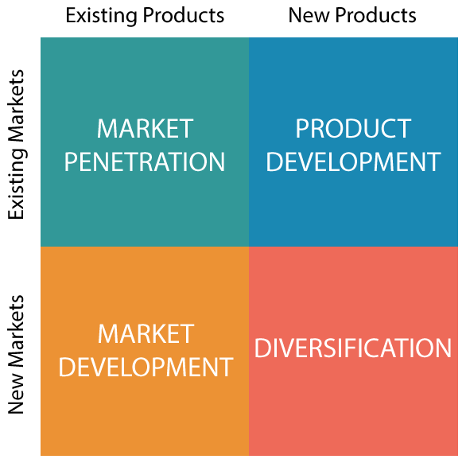Samsung has positioned itself as a lead user in the development of flexible displays due to its commitment to develop foldable phones earlier than the rest of the competition in the smartphone industry. Given the cutting-edge nature of these products however, there is little potential for custom product or service design as Samsung are focused on refining the core product that they are producing, which by itself is relatively unique by design, and therefore does not require custom design in order to differentiate itself. This process of focusing on core product development is evocative of operations which pertain to the upper right quadrant of the Ansoff Matrix, as seen in Fig. 4 (Ansoff, H.I., 1957). However, feedback from external sources will still play an integral role in determining the product development process, as Samsung's iterative approach to its product releases will allow it to quickly improve the product, and it can receive progressive feedback accordingly. Notably, this approach allows the company to leverage the feedback it receives from lead users in the form of tech reviewers, who represent highly knowledgeable opinion leaders. This is significant as markets “respond more favourably to reviews written by reviewers with better reputation and higher exposure.” (Hu, N., Liu, L. and Zhang, J.J., 2008). Through this feedback an understanding of customer judgements of substitutability can be established, as this process will reveal to Samsung which measures, or new features have been most important in contributing towards the notion that its foldable phone line is becoming a suitable substitute for traditional phones and tablets. This information will be critical to conducting decision sequence analysis. (Day, G.S., Shocker, A.D. and Srivastava, R.K., 1979, pg 13-15). Hence, opinion leaders will be essential lead users in the development process through the aforementioned feedback mechanisms, though despite these users importance, ultimately consumer judgement will be paramount in shaping the development process.

**Bibliography**

* Ansoff, H.I., 1957. Strategies for diversification. *Harvard business review*, *35*(5), pp.113-124.
* Day, G.S., Shocker, A.D. and Srivastava, R.K., 1979. Customer-oriented approaches to identifying product-markets. *Journal of marketing*, *43*(4), pp.8-19.
* Hu, N., Liu, L. and Zhang, J.J., 2008. Do online reviews affect product sales? The role of reviewer characteristics and temporal effects. *Information Technology and management*, *9*(3), pp.201-214.
* Scarsella, A. and Stofega, W., 2019. *Worldwide Smartphone Forecast Update, 2019–2023: December 2019*. Research Manager, Mobile Phones ,. [online] International Data Corporation. Available at: <https://www.idc.com/getdoc.jsp?containerId=US45708819> [Accessed 31 March 2021].
* Shocker, A. D., Bayus, B. L. and Kim, N. (2004) ‘Product Complements and Substitutes in the Real World: The Relevance of “Other Products”’, Journal of Marketing, 68(1), pp. 28–40. doi: 10.1509/jmkg.68.1.28.24032.

**Appendix**

**Fig 1:**

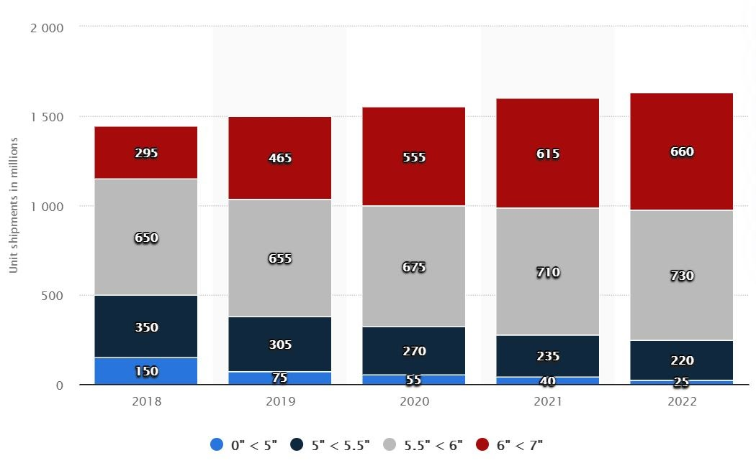

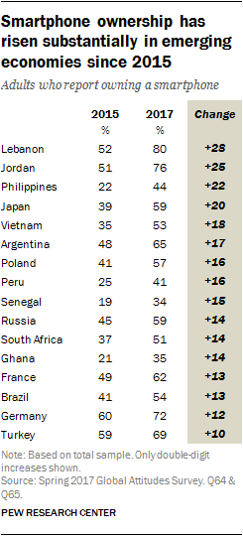

**Fig 2:**